**DAILY ONLINE ACTIVITIES SUMMARY**

|  |  |  |  |  |  |  |  |  |
| --- | --- | --- | --- | --- | --- | --- | --- | --- |
| **Date:** | **01/06/2020** | | | | | **Name:** | **Katira Krishna J** | |
| **Sem & Sec** | **8th A** | | | | | **USN:** | **4AL16CS045** | |
| **Online Test Summary** | | | | | | | | |
| **Subject** | | **SMS** | | | | | | |
| **Max. Marks** | | **60** | | **Score** | | | **30** | |
| **Certification Course Summary** | | | | | | | | |
| **Course** | **Machine learning with python** | | | | | | | |
| **Certificate Provider** | | | **Cognitiveclass.ai** | | **Duration** | | | **5 Hours** |
| **Coding Challenges** | | | | | | | | |
| **Problem Statement: Determine Pythagorean Triplets using python** | | | | | | | | |
| **Status: Completed** | | | | | | | | |
| **Uploaded the report in Github** | | | | | **yes** | | | |
| **If yes Repository name** | | | | | **Krishna_Katira** | | | |
| **Uploaded the report in slack** | | | | | **yes** | | | |

Online Test Details:

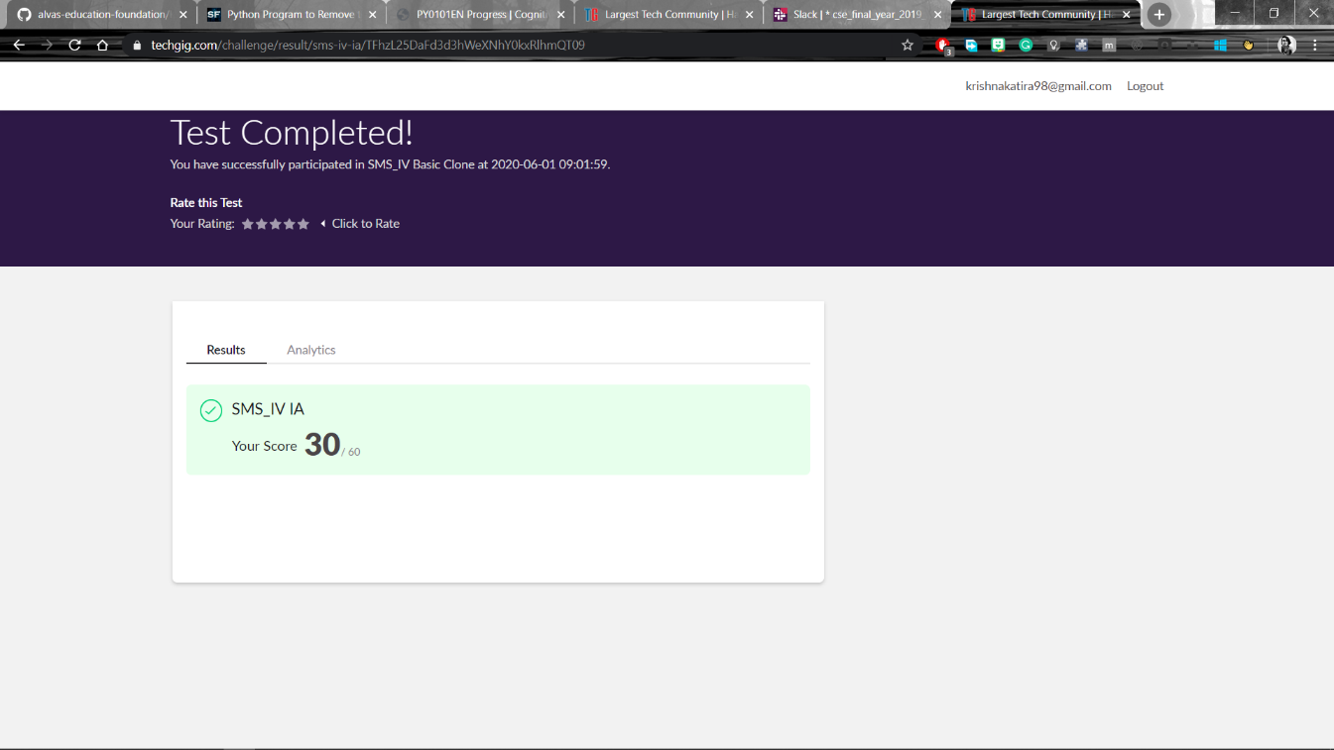

Certification Course Progress:

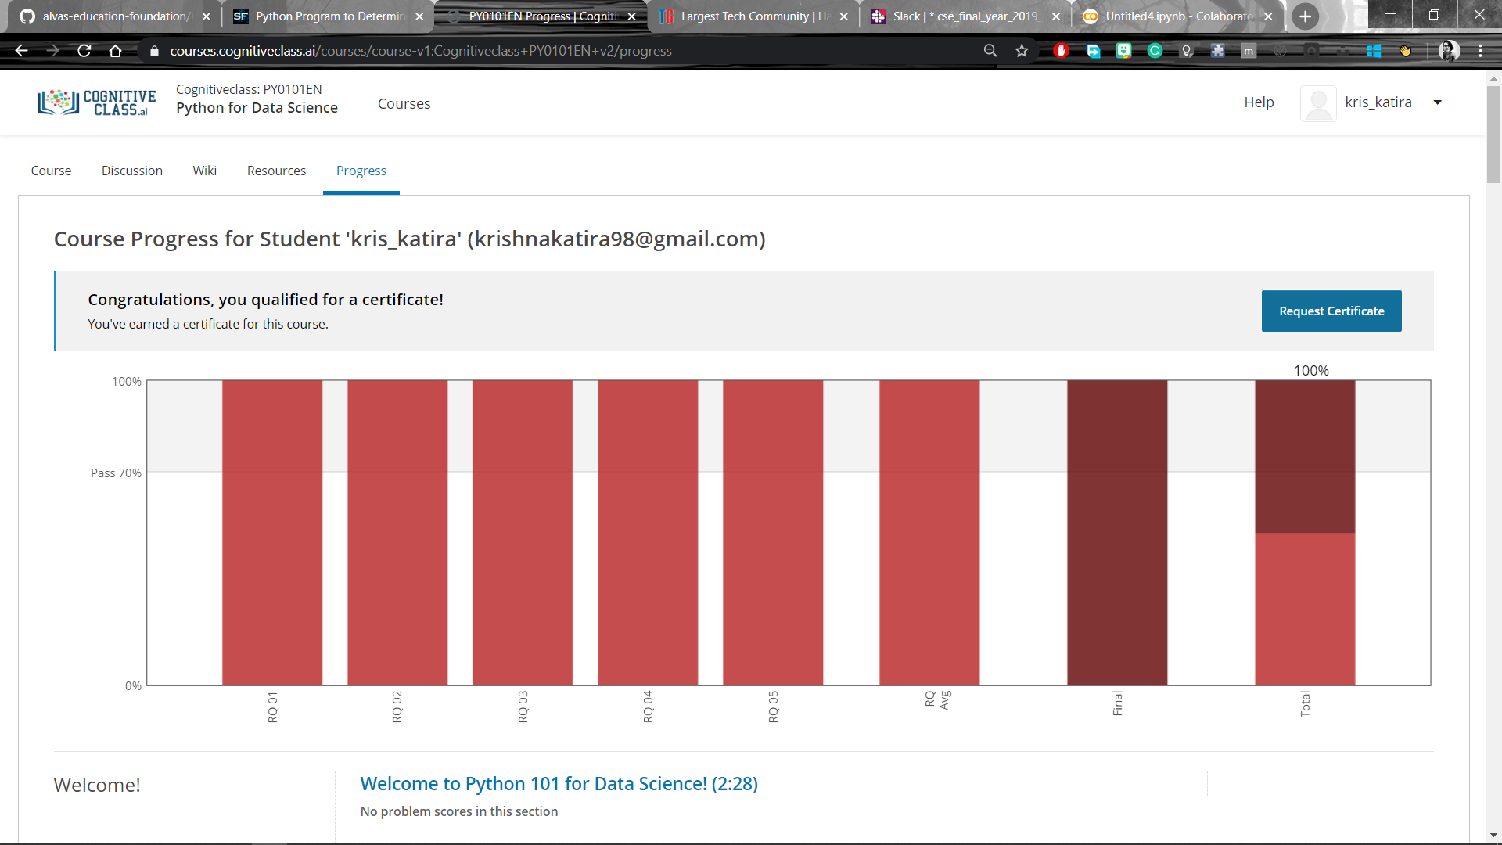

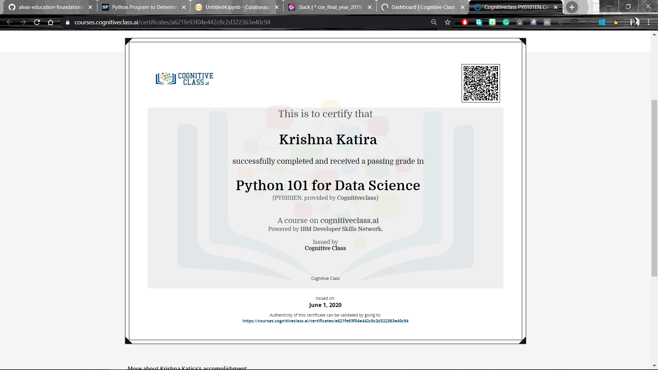

Coding Challenges Details:

**program1**

limit=int(input("Enter upper limit:"))

c=0

m=2

while(c<limit):

for n in range(1,m+1):

a=m*m-n*n

b=2*m*n

c=m*m+n*n

if(c>limit):

break

if(a==0 or b==0 or c==0):

break

print(a,b,c)

m=m+1